

***Assembly Line Assessment and Optimization***

Course Title: Operations Research

Course Number: ETM 540

Instructor: Dr. Timothy Anderson

Term: Fall

Year: 2019

Author(s): Shivani Agarwal, Kyle Brown, Jesse Fritz, Harshita Gadiraju, Chaitali Sawant

ETM OFFICE USE ONLY  
Report No.:   
Type: Student Project  
Note:

Contents

**Introduction** **3**

**Current Situation** **3**

**Project Focus** **4**

**Literature Review** **4**

**Methodology** **5**

Data and Model Formulation **6**

**Current Assembly Line Performance** **7**

**Initial Results** **8**

**Modified Assembly Line Performance** **10**

**Final Results** **12**

**Conclusion / Recommendation** **13**

**References** **16**

**Appendix A - Original Task Data** **18**

**Appendix B - Modified Task Data** **21**

**Appendix C - R Model** **24**

**Appendix D - Worker maximum limit** **28**

# Introduction

Silver Eagle Manufacturing Company (SEMCO) is an established manufacturer of on-highway transportation and support equipment. One of the products significantly contributing to revenue is a medium sized delivery trailer called the TP60. The trailer is primarily used in rural environments by being hooked up to a standard delivery van or to a regular pickup truck. The trailer was developed 7 years ago as a replacement to the TP45, designed with an increase in capacity. The TP60 also has the potential to support new last mile delivery modes by acting as a portable parcel sub-hub for smaller delivery vehicles to be loaded from. Last mile delivery is the most costly step in supply-chain delivery management, accounting for nearly 25% of total delivery costs for a company (Boyer & Prud’homme, 2009). Because of this, the forecast for future production of the trailer is good with at least 5 more years of scheduled production before a further redesign is considered.

# Current Situation

The TP60 assembly line at SEMCO consists of 7 stations arranged in a linear fashion. The current task distribution for assembly is sequential and may not be altered significantly due to the ordinal nature of the tasks and limited available space in the warehouse. In the early development of the line, only 2 trailers per day were produced. The line has evolved over the years with small changes attempting to balance cycle times between stations to maintain consistent flow and output. There have been instances where SEMCO was able to manufacture 4 units per day utilizing overtime hours but typical volume is currently 3 units a day, with total employees and total human hours held constant. The normal working day is 10 hours including stretching, lunch, and breaks. A daily quota of 3 units allows for 3.06 hours for every simultaneous station move of the assembly line.

# Project Focus

The SEMCO operating managers were candid in admitting that the current production model was not sufficiently analyzed from the outset. As a result, the current production model is likely rife with inefficiencies. A balanced assembly line can optimize line efficiency and increase the rate of production, leading to increased profits and decreased costs (Patil, Tonape, & Umrani, 2016). Inefficiencies in a line can quickly compound and lead to a company not fully realizing their potential given its current array of resources. The desire is to revisit the assembly line and associates tasks to identify slack, parallel tasks, and additional line balancing that would allow for the manufacture of 4 trailers per day within the current constraints of the line - a 33% gain in daily output. Optimizing a sequential line production model is often more of a challenge than a traditional production model due to the inflexibility of task ordering, the smaller number of tasks to optimize and the variability in production times across a smaller sample size (Boling, 1972). This may be seen in the variability of the averages across the stations in the SEMCO production line. During the summer of 2019, a MECOP intern collected time study data for all 7 stations, looking at 101 individual tasks that could be grouped into 31 sub tasks. This time data will be used to analyze the existing assembly line per the operating managers concerns with a goal to present a possible solution to produce 4 trailers per day.

# Literature Review

Linear programming is a mathematical programming technique designed to find optimal production while incorporating a set of resource constraints such as necessary output, number of employees, space limitations, etc. that come from the direction of an organization (Aregawi, 2018). Constraints also arise from simple things like the fact that a company cannot produce negative amounts of a given product, necessitating the inclusion of lower bound constraints on a given product or resource.

Traditional production methods have been slowly replaced by assembly lines as manufacturers are facing unprecedented pressure to produce products in a shorter cycle time and remain competitive in terms of price (Mircea, 2012). Typical modern assembly line examples include an arrangement of work stations, either linear or circular, each with predetermined tasks that must be performed in sequential order. In manufacturing plants, the assembly lines usually maintain a store of components to be assembled in the finished parts. Major factors determining the success of assembly lines are evenly split workloads between all of the stations, similar and consistent cycle times of each station, and clearly defined sequences that must be followed with high quality and efficiency (Aregawi, 2018).

# Methodology

The methodology used in our project to collect the data for assembly line is time study methodology. The data collection began after the line was at full production to account for new employees and reduce data skewed by startup learning curves. Sequential processes were listed or each station with parallel tasks accounted for. Since line employees were cross trained at all the stations, two readings were taken at each station to identify the reasonable time range in which tasks should be able to be completed during the normal work day with workers of varying skill levels. The maximum and minimum time readings for each task were averaged and totalled indicating the actual workload demanded of each station. The workload was divided among the workers in the station resulting in a resource input referred to as man hours.

Linear programming techniques and sensitivity analysis were used for the data analysis and optimization of the resources. Using sensitivity analysis, the shadow prices of the current production plan are identified. Also known as row duals, the shadow prices tell us how much of each resource is required to meet the next quantity of output desired. The next logical step in the TP60 assembly line is to increase daily production from 3 to 4 per day. Based on the results, the study was further extended by analyzing the data to indicate if proper line balancing is achieved necessary to reach an optimized sequential line production model.

# Data and Model Formulation

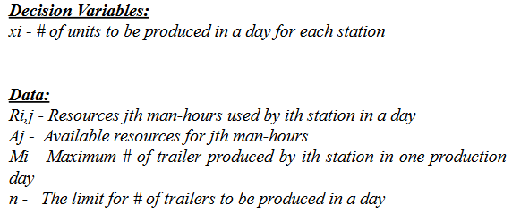

***Objective function:***

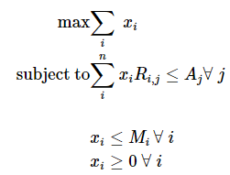

The above LaTeX formulation shows the objective function of maximizing the number of production units at each station.

* **xi** is the decision variable, stating # of TP60 trailers to be produced in a day at each station.
* We have three data variables:
  + Firstly, **Rij** which is resources of *jth* man-hours used by the *ith* station.
  + **Aj** is the maximum available resource for *jth* man hours.
  + **Mi** is the maximum number of trailers to be produced by the *ith* station.
* The three constraints are as follows:
  + **Rij**, Resources of *jth* man-hours used by *ith* station for producing TP60 trailers **xi** at each station should be less than or equal to the maximum available resources **Aj**
  + Number of units produced by *ith* station should be less than or equal to the maximum number number of trailers **Mi**
  + And finally, a non negativity constraint, number of units to be produced by each station should be greater than or equal to 0.

It has the following R code attached in the Appendix C.

# 

# Current Assembly Line Performance

The historic evolution of the TP60 line results in a flow of sequential tasks. There appears to be some consideration for balancing the workload of each station although there is variability in cycle times, ranging from 2.15 hrs to 2.81 hrs. Due to an available cycle time of 3.06 hrs, the range in cycle times results in 3.87 hrs of total slack for all of the stations per cycle. The current production for the assembly line is three (3) completed TP60 trailers per day, with the distribution of workers as follows:

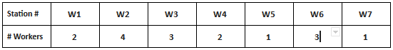**Table 1:** **Current Allocation of Workers**

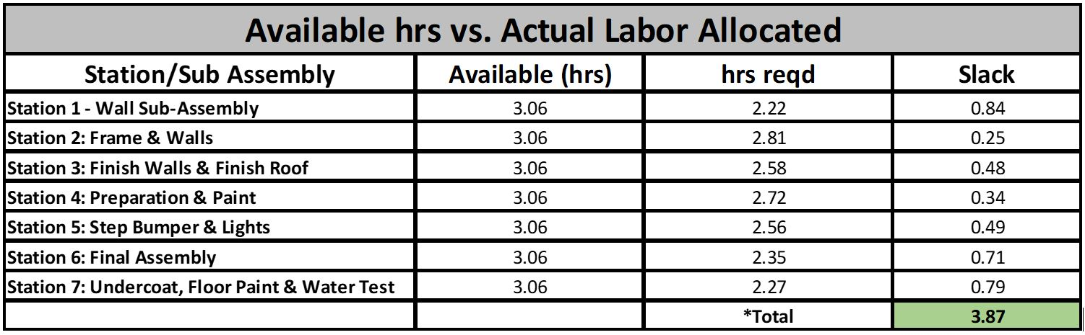

**Table 2 : Required time and slack at each station**

The above table shows the number of hours required for each station to complete the task with the slack of 3.87 hrs as the difference between the available 3.06 hrs and required hours at each station.

# Initial Results

On the basis of the MIP model in Appendix C, we can see below the number to TP60 trailers to be produced by each station:

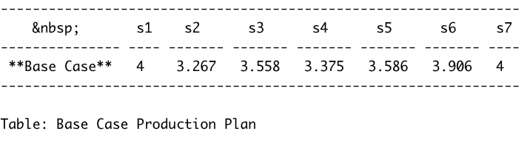

**Fig 1 : Initial Production plan**

In the initial production plan, only stations 1 and station 7 are presently identified as being capable of meeting the target of 4 TP60 trailers produced per day. Stations 2-6 are presently incapable of producing 4 TP60’s per day. Therefore, for stations 2-6, there exists a need for additional resources, increased task efficiency, or task parallelism to produce 4 trailers per day.

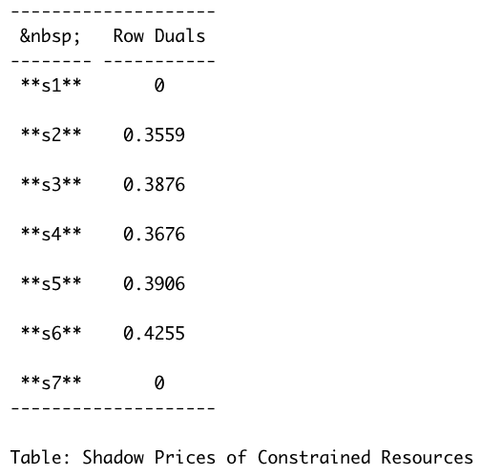

**Fig 2: Shadow prices for Original Model**

From the result of shadow prices for the original model shown in the above table(fig. 2), it is observed that stations 1 and 7 have 0 shadow price/row duals, which means they may have non-utilized resources available, which could then be re-allocated amongst the systems that are not meeting the needed production. Fig. 2 shows that for stations 2 through 6, adding one additional man hour will help in producing the respective amount of additional TP60 mentioned in the row duals. For example, at station 2, if one man hour is added, then the station will produce 0.3559 TP60 trailers.

Our target is to produce 4 TP60 trailers in a production day for all stations. To achieve this objective, we need to analyze the total resources available at each station and how many additional resources are required to reach the desired target. Accordingly, we have set the target for each station to be 4 TP60 trailers. From the initial production plan, we know the current capability of production at each station and then accordingly calculated the resources man hours required to achieve the target.

From the results of shadow prices, we calculated the man hours required (resources) to attain the ultimate goal. For example, station 2 will require total 2.06 man-hours to be capable of producing 4 TP60 trailer as shown in the below table.

|  |  |  |  |  |  |  |
| --- | --- | --- | --- | --- | --- | --- |
| **Required Man Hours for Producing 4 TP60 Trailers by Each Station** | | | | | | |
| **Stations** | **Trailers to be produced** | **Station capability** | **Required TP-60** | **Row Duals** | **Man-hrs required** | **Suggestion** |
| station 2 | 4 | 3.267 | 0.733 | 0.3559 | 2.06 | Workers maxed out ; reduce time |
| station 3 | 4 | 3.558 | 0.442 | 0.3876 | 1.14 | Add 1 worker from station 4 |
| station 4 | 4 | 3.375 | 0.625 | 0.3676 | 1.70 | Reduce 1 worker ; reduce time |
| station 5 | 4 | 3.586 | 0.414 | 0.3906 | 1.06 | Add 1 new worker, move 1 worker from 6 |
| station 6 | 4 | 3.906 | 0.094 | 0.4255 | 0.22 | Reduce 1 worker ; reduce time |

**Table 3: Required man hours by stations for in order to produce 4 TP60’s**

We have the limitation of the maximum number of workers that can be allocated to each station depending upon the availability of physical space at the station. From Appendix D, we can see that station 2 already has the maximum number of workers allocated. Also, it the maximum number of man hours are required for new production. The above reasons result in a bottleneck at station 2 . Since station 1 is already capable of making 4 TP60 trailers, we need to have a solution to pass the bottleneck at station 2. The two possible solutions to move forward are:

* Reduce the tasks from this particular station - not easily done as we cannot directly reduce 2.06 hours from a station.
* Move some of the sub-tasks and workers to other stations.

After considerable analysis of the data from the assembly line, the second solution to move subtasks through the reshuffling of workers among stations was chosen as the better solution in order to reach the ultimate goal.

# Modified Assembly Line Performance

Based on the observations and analysis on the current assembly line, modifications were implemented for revised production plan by expanding station 1 and reducing the workload at station 2. Modifications are further done by increasing the tasks and workers at some of the stations and reducing the workload on other stations in order to have a balanced cycle time.

**The modifications to the current assembly line are as follows:**

* At station 1, we added one new worker and moved task 24 of group task H from station 2, related to the assembly of the walls of the trailer, from station 2.
* At station 2 (which is the bottleneck), we moved the task 24 from group H to station 1 as it is the most time taking task of 43.97 minutes. No change in the number of workers.
* At station 3, we moved one worker and task N, related to cleaning and painting, from station 4 and added to station 3.
* At station 4, we reduced one worker shifted Task N, related to the preparation and installation of the doors, to station 3.
* At station 5, we added one new worker and moved one worker and task V, from station 6.
* At station 6, we moved one worker and task V to station 5.
* At station 7, no changes were made.

|  |  |  |  |  |  |
| --- | --- | --- | --- | --- | --- |
| **Station number** | **Man hrs* Required** | **Allocated Workers** | **hrs rqd** | **Tasks** | **Workers** |
| station 1 | 4.97 | 3 | 1.657 | Moved task 24 from group task H to station 1 | Added one new worker |
| station 2 | 9.01 | 4 | 2.253 | Reduced task 24 and added to station 1 | - |
| station 3 | 8.45 | 4 | 2.113 | Task N added from station 4 | One worker moved from station 4 |
| station 4 | 2.06 | 1 | 2.060 | Reduced task N | Reduced one worker |
| station 5 | 5.01 | 3 | 1.670 | Task V is added from station 6 | One new worker and one worker from station 6 added |
| station 6 | 4.59 | 2 | 2.295 | Reduced task V | Reduced one worker |
| station 7 | 2.27 | 1 | 2.270 | - | - |

**Table 4: Modified Assemble line**

The modified workers allocation with two new workers added to the assembly line is shown below

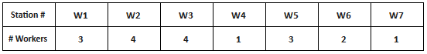**Fig 3: Modified Allocation of Workers**

# Final Results

On the basis of the modified MIP model, we can see below the number of TP60 to be produced by each station with the upper bound/maximum limit as 5 TP60 trailers :

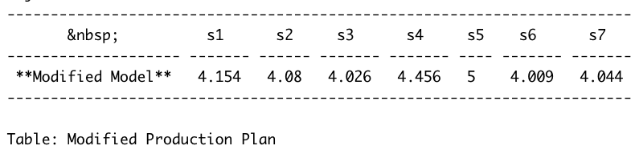

**Fig 4: Production Plan for 5 TP60**

Running the modified model with an upper bound of 5 yields row duals for each station to produce 5 TP60 per day.

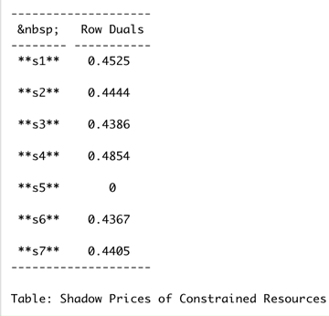

**Fig 5: Shadow Prices for Modified Model**

# The above results show that the assembly line is now able to at least produce 4 TP60 trailers. Here, we can see station 5 is able to make 5 TP60 trailers whereas other stations can produce 4 TP60 trailers with some slack time. Also, from the shadow price results, we can see how at station 5 there are some non utilized resources. Whereas, for all other stations all the resources are completely utilized.

Below table 5 shows the slack calculation from initial and modified production plan. As reflected in the table, we can see that slack has been reduced from 3.87 hrs to 1.30 hrs with an

increase of one unit of TP60 trailer in the production plan along with the addition of 2 workers.

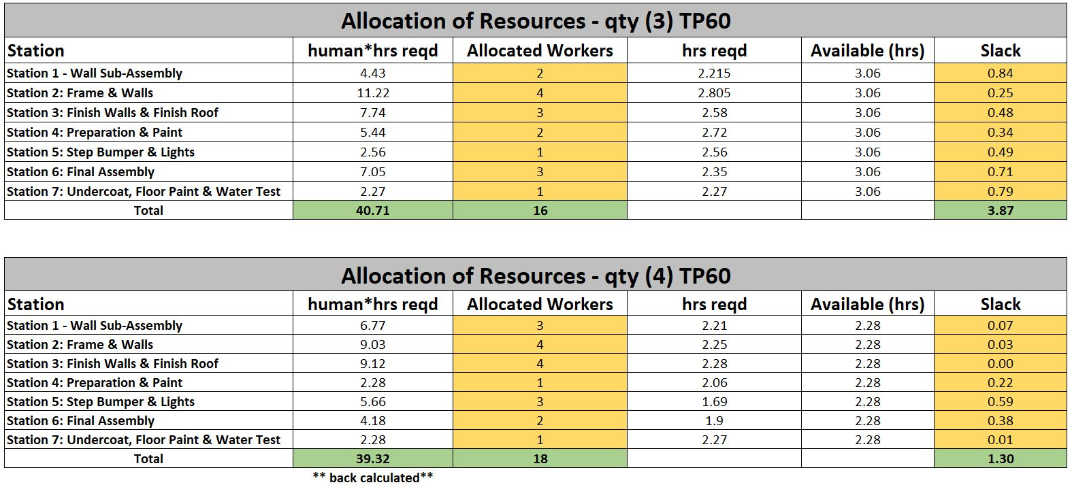

**Table 5 : Allocated workers and station slack comparison for the modified assembly line**

# Conclusion / Recommendation

Station 2 is maxed out on workload and maxed out with workers. The current production limitations of station 2 is setting the capacity for the entire assembly line. Since it is currently infeasible to add another station or run stations in parallel, station 2 becomes a bottleneck for capacity and also hinders the balancing of workload between other stations.

Assembling a nearly completed body before joining to a frame is a technique used in automobile manufacturing known as Body in White, or BIW (Mayyas, 2011). BIW assembly has several advantages over other assembly techniques. First, the dimensional accuracy of highly aesthetic body panels are held relative to each other rather than being associated with unseen chassis features. The alignment of panel seams and trim pieces are critical to the visual quality of large body structures. Quality control inspection of the BIW technique often entails gap measurement, surface alignment measurement, and the allowable deviation along each panel relative to other panels. The body panels are typically made of lightweight materials as opposed to heavy structural components of the chassis and even small deviations can add difficulty for assembly. If manufacturing tolerance stacks up between chassis components and body components are at opposing limits of deviation, excessive manipulation could be required during fit up. Excessive manipulation often results in undesirable maring and/or permanent warping of the body panels. Lastly, combining chassis and the BIW technique allows an opportunity to adjust the two sub assemblies relative to each other, satisfying both the appearance and functional requirements of the completed vehicle. Shimming or manipulation at this stage in assembly occurs in predetermined connection locations typically with accommodations provided for pre approved methods. Adjusting two large rigid bodies through a controlled process is far more efficient than manipulating separate components on an individual basis.

We were able to simulate a production rate of 4 TP60 units per day by making the following adjustments to the production line:

* Expanding the station 1 assembly cell to complete more of the body assembly work will reduce workload on station 2 and allow stations 1-3 to be more balanced.
* Increasing the total number of workers on the line from 16 to 18.
* Increase the total number of workers at station 1, 3 & 5 by 2 workers.
* Reduce the total number of workers on stations 4 and 6 by 1 worker.
* Shifting individual tasks to stations having slack from the one not able to meet the requirement or inefficient.

These adjustments offer a feasible solution for SEMCO to increase their daily production from 3 trailers to 4 trailers. The presentation of the solution was well received by SEMCO production management. They stated the optimal financial plan of the TP60 line was to produce 4 per day but they had never been able to achieve the goal on a consistent basis. The presentation sparked a lengthy conversation about additional improvements and implications within the line even considering an entire new layout of the line based on our concept of expanding station 1. The BIW assembly method had not been considered in the past. The presentation concept also lead to a discussion of decoupling of the BIW and chassis lines to create 2 lines that could operate independently and adjusted to account for unexpected employee absences and/or vacations.

Manufacturing companies face unknown challenges on a daily basis. The discussion with SEMCO management gave us great insight into how the human factor should be considered alongside the data. Different industries, company cultures, and even geographic locations create unique challenges that should be considered case by case when implementing optimization of human activities. It is important to analytically discuss with an experienced group about how data as well as human factors combine to influence the desired goals and results of any optimization project.

# References

1. Aregawi, B.Z. (2018). Formulating and solving a linear programming for product-mix linear problems with n products. *International Journal of Engineering Development and Research, 6* (2), 167-171.
2. Bahremand, S. (2015). Analyzing manufacturing company’s production lines efficiency using data envelopment analysis. *Indian Journal of Science and Technology,**Vol 8(27), DOI: 10.17485/ijst/2015/v8i27/82777.*
3. Boling, R. (1972). How to analyze sequential work systems. *American Institute of Industrial Engineers, 2* (2), 12-18.
4. Hillier, F. S., & So, K. C. (1996). On the simultaneous optimization of server and work allocations in production line systems with variable processing times. *Operations Research*, *44*(3), 435-443.
5. Mayyas, A.T., Qattawi, A., Raouf Mayyas, A., Omar, M.A. (2011). Life cycle assessment-based selection for a sustainable lightweight body-in-white design. *Sustainable Energy and Environmental Protection, 39* (1), 412-425.
6. Mircea, A. (2012). Main aspects concerning PCB manufacturing optimization. *Circuit World*, *38*(2), 75-82.
7. Patil, K., Tonape, S., & Umrani, A. (2016). Assembly Line Optimization Using Lean Principles.
8. Saptari, A., Leau, J. X., & Nor Akramin, M. (2015). Optimizing assembly line production through line balancing: A case study. *Applied Mechanics and Materials, 761,* 104–108.
9. Shi, H., & You, F. (2015). A novel adaptive surrogate modeling‐based algorithm for simultaneous optimization of sequential batch process scheduling and dynamic operations. *American Institute of Chemical Engineers Journal*, *61*, 4191–4209.
10. Su, Q., Liu, L., & Whitney, D.E. (2010). A systematic study of the prediction model for operator-induced assembly defects based on assembly complexity factors. Systems, Man and Cybernetics, Part A: Systems and Humans, IEEE Transactions on 40.1 : 107-120.
11. Xu, R. Y., Shi, H. F., & Zhou, S. G. (2009). Cost optimization of PVC enterprise based on process manufacturing optimization model. *2009 International Conference on Machine Learning and Cybernetics*, 5, 2513-2516.
12. Yerasi, P. (2011). Productivity improvement of a manual assembly line. *Texas A&M Univ. Texas Master’s Thesis*.
13. N.N , (N.D). Assembly line Balancing. *Retrieved from*

<https://www.whatissixsigma.net/assembly-line-balancing/>

# 

# Appendix A - Original Task Data

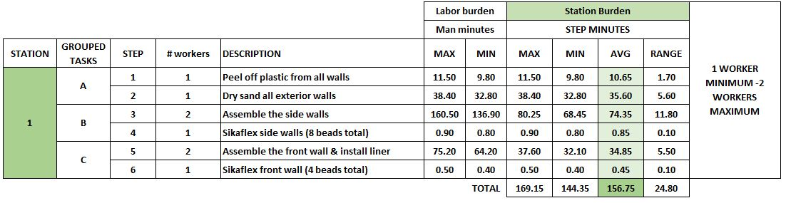

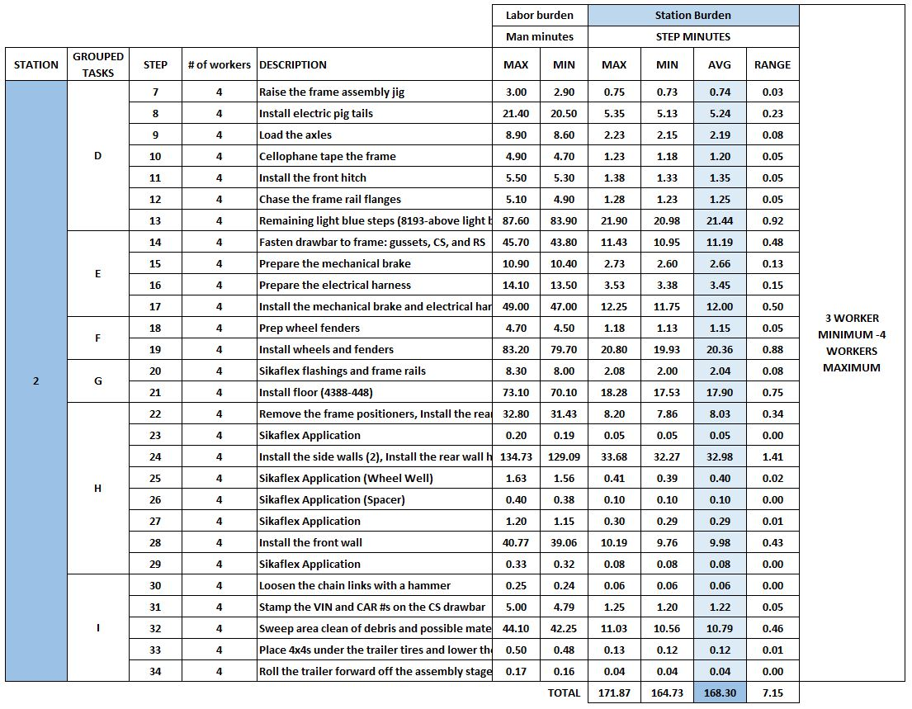

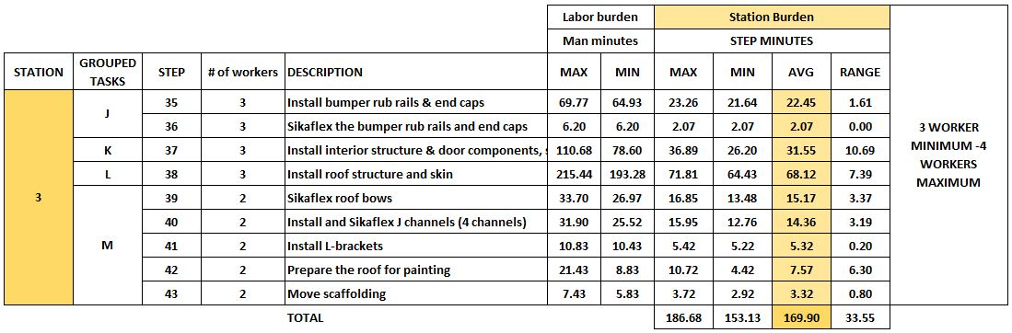

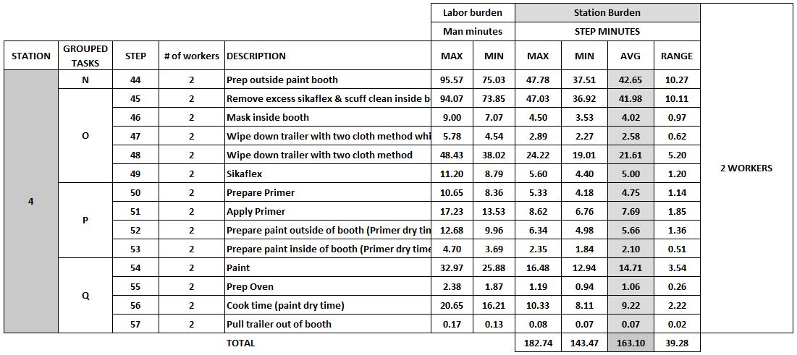

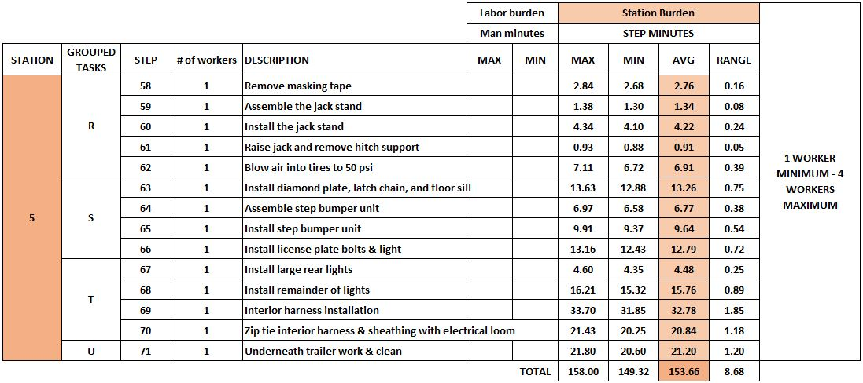

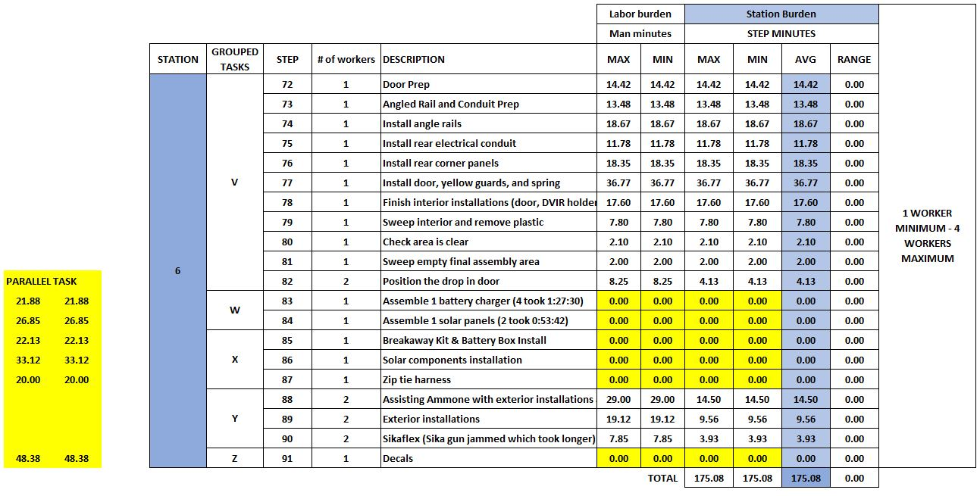

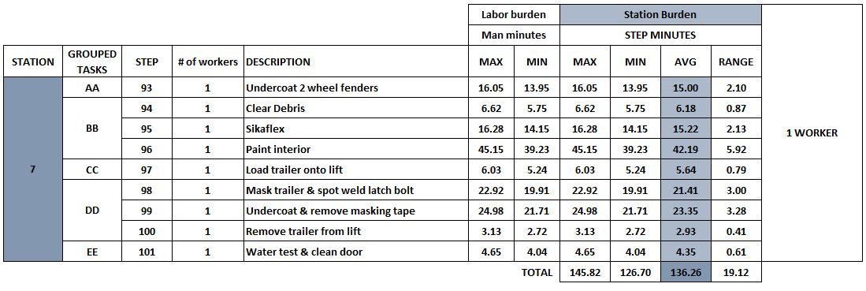

# Appendix B - Modified Task Data

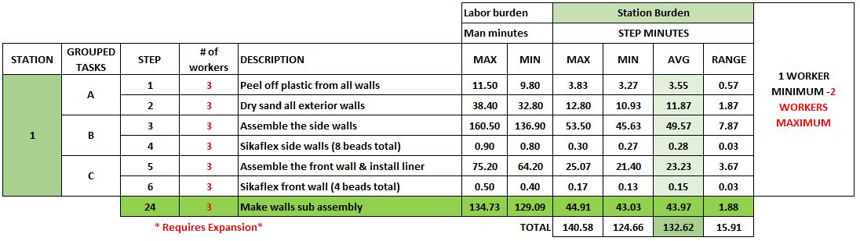

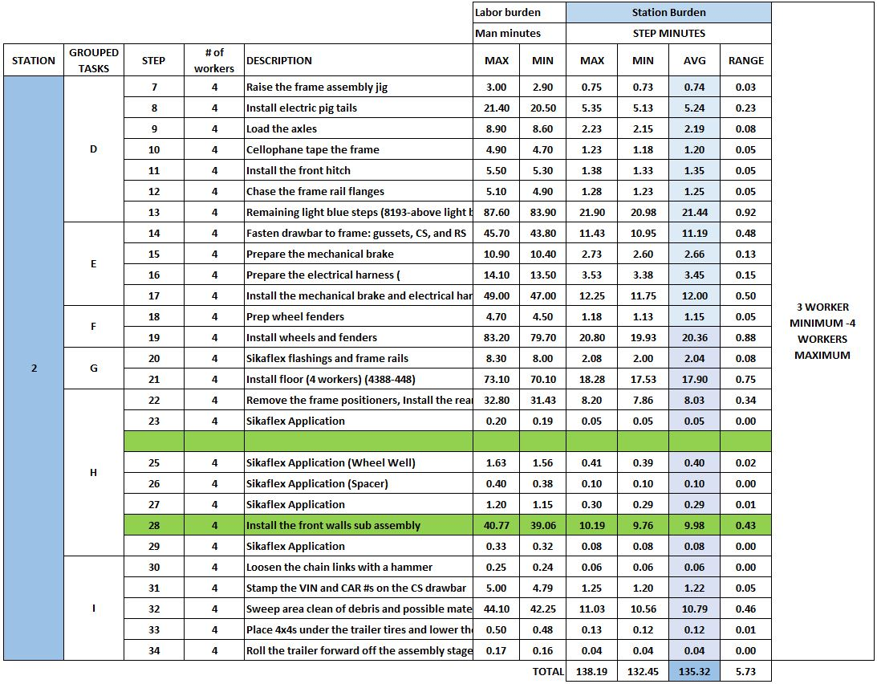

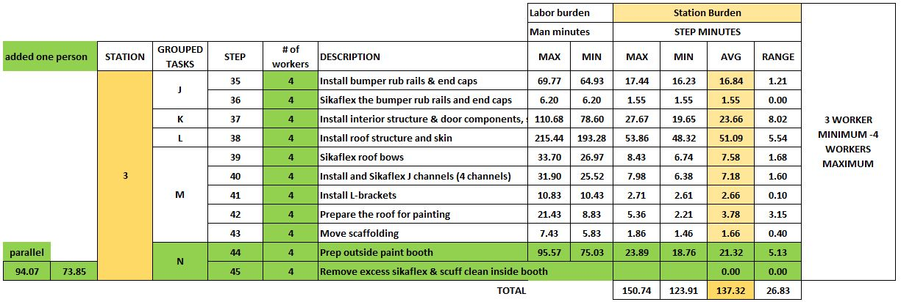

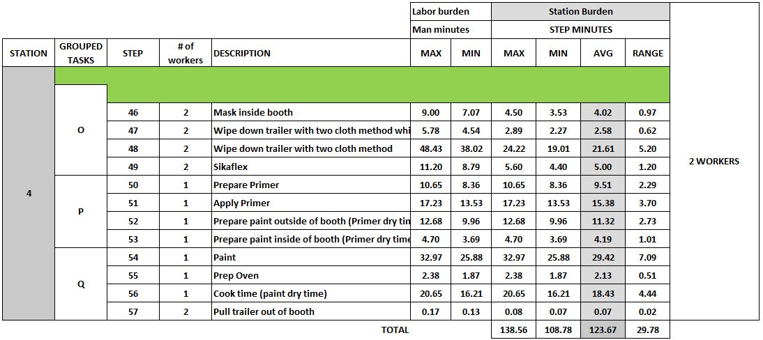

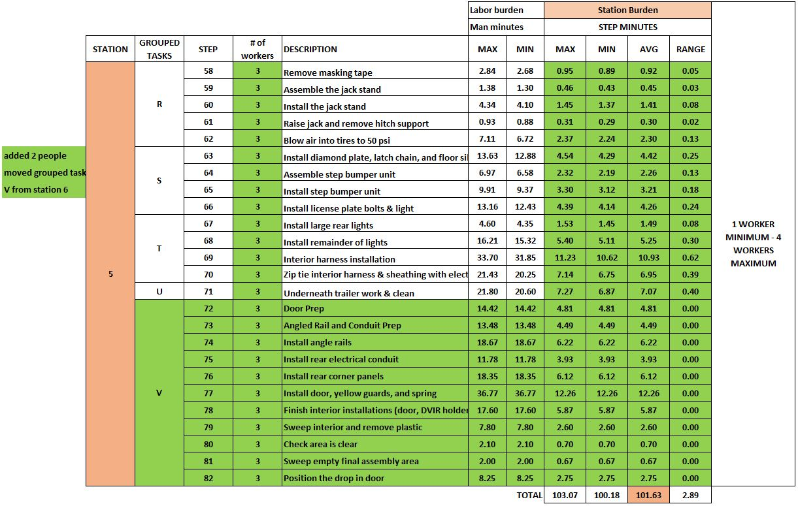

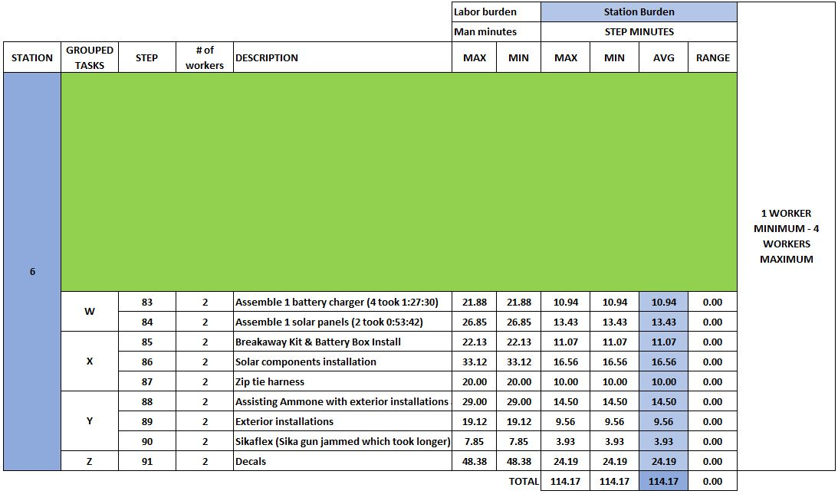

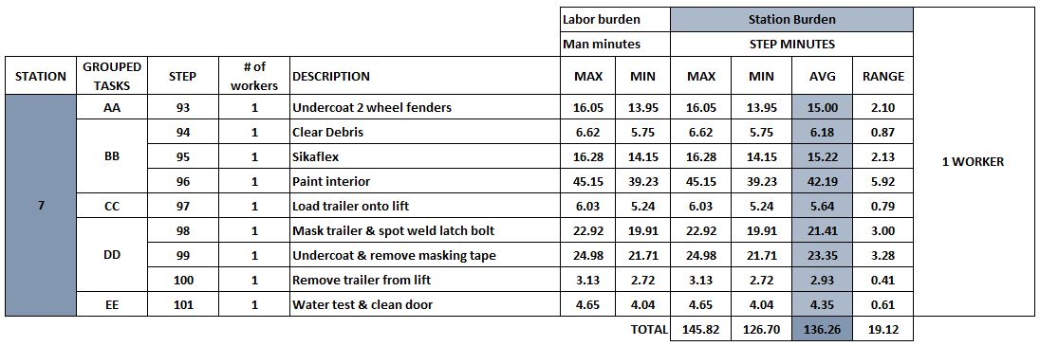

# Appendix C - R Model

# **Production Plan**

## **R Markdown**

**Initial Production Plan**

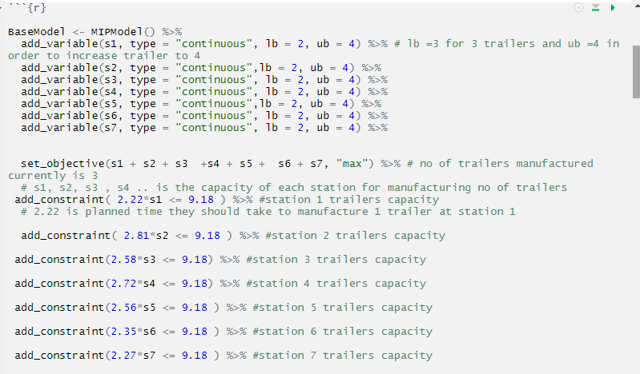

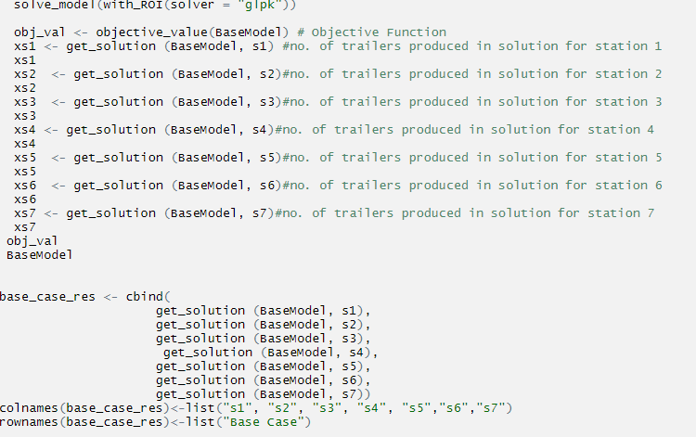

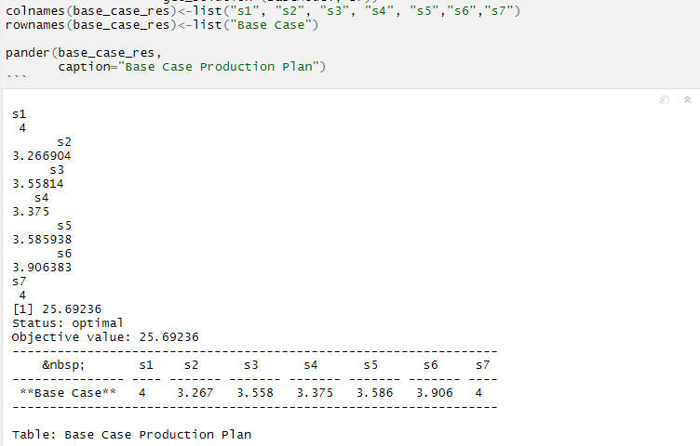

**Shadow prices / Row Duals for Initial Production Plan**

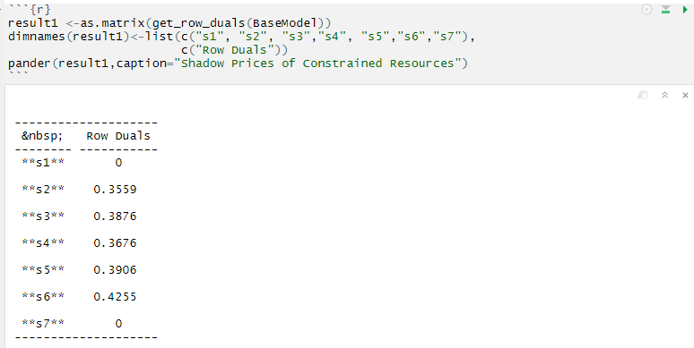

**Modified Production Plan**

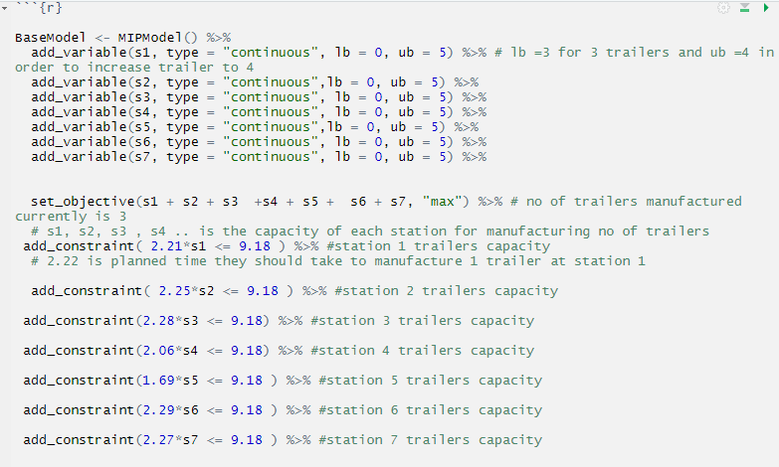

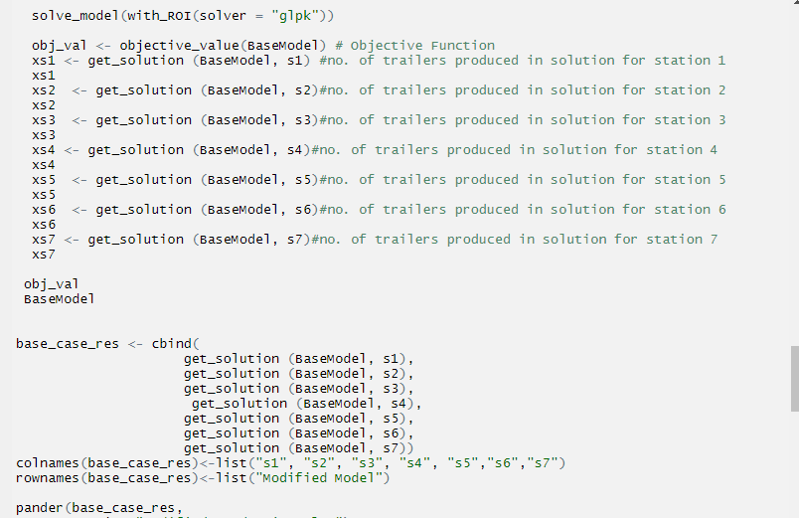

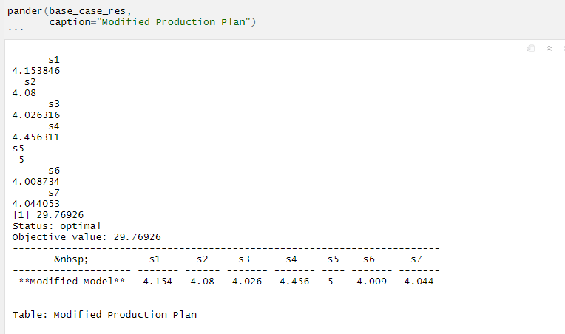

**Shadow prices / Row Duals for Modified Production Plan**

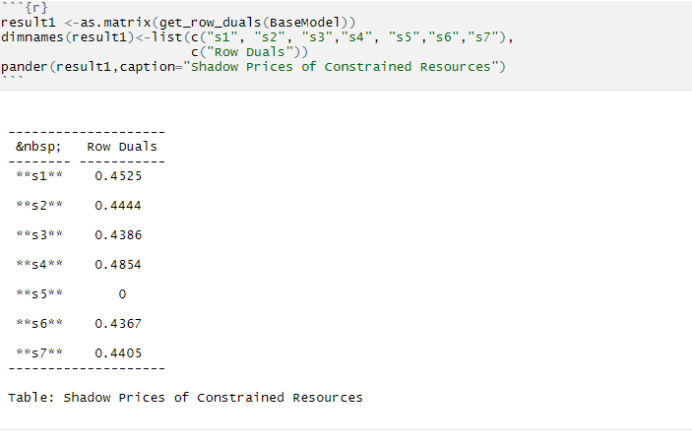

# Appendix D - Worker maximum limit

|  |  |  |  |
| --- | --- | --- | --- |
| **Workers Allocation** | | | |
| **Stations** | **Maximum available allocation** | **Currently allocated** | **Modified no of Workers** |
| station1 | 2 | 2 | 3 |
| station2 | 4 | 4 | 4 |
| station3 | 4 | 3 | 4 |
| station4 | 2 | 2 | 1 |
| station5 | 4 | 1 | 3 |
| station6 | 4 | 3 | 2 |
| station7 | 1 | 1 | 1 |